Acknowledgement

Table of Contents

Contents

Self-Appraisal form 4

Personal Objectives – Performance measurement 5

Risk Analysis 5

Collaboration Document 6

Evidence of good collaboration 6

Good communication and file sharing 6

Continuing Personal Development (CPD) 6

Appendix A 6

1.Risk Analysis Report 6

1.1 Introduction 6

1.2. Risk Management Plan 7

1.3. Qualitative Risk analysis 7

1.4. Plan and control risk responses. 12

[2]. Project and People Management 14](#_Toc164980039)

2.1. Gantt Chart 14

[2.2.] Slack 15](#_Toc164980041)

[2.3]. Meeting Minute 18](#_Toc164980042)

[2.3.1.] First Meeting with Client minute 18](#_Toc164980043)

[2.2.2]. Second Meeting with client minute: 19](#_Toc164980044)

[2.2.3]. Third Meeting with clients: 20](#_Toc164980045)

[3.2.4]. Backlog Review Meeting among team members. 21](#_Toc164980046)

[3.2.5]. Product backlog and Sprint planning 23](#_Toc164980047)

[3.2.5]. Epics , User Story and task related 25](#_Toc164980048)

[3.2.6]. Sprint 1 Retrospective Discussion 27](#_Toc164980049)

# Self-Appraisal form

|  |  |  |  |
| --- | --- | --- | --- |
| Student number | 2358577 | Name | Pankaj Kumar Mahato |
| Project | Gantavya Car Rental Service | Date | 2024/04/01 |
| Role | Project Manager (PM) | Team | Group 3 |
| Sprint (1 or 2) | 1 |  |  |

# Personal Objectives – Performance measurement

|  |  |  |  |
| --- | --- | --- | --- |
| **Objectives** | **Evidence provided** | **Evaluation**  Student / tutor | |
| Risk Analysis | I believed that I had did better performance for risk analysis of our project. Beginning of the project, I started planning and identify the risks that might occur within the project period. The risk like absentees of BA, late completion of the work, technical issue, environmental issue etc. While starting there was also huge issues and conflict among our team members. There was communication gap between me and our developer’s team. We are trying to resolved or mitigate this risk whose documentation is below in **Appendix A.** | 8.5/10 |  |
| Tutor feedback: | | | |
| People Management | I think I did better job for managing my team of Car Rental Website Project even after huge conflict among team members. For communication, we had used different social media like College Gmail Space and slack. We also used to communicate directly by scheduling physical meetings in college and taking notes of discussed topic in every meeting either that would be client or team members meeting. During meeting, we had also taken meeting minute containing the Attendance, Agenda, notes and Action item whose documentation in below on **Appendix A.** | 9/10 |  |
| *Tutor feedback:* | | | |
|  |  | 17.5/20 | /20 |

# Collaboration Document

## Evidence of good collaboration

## Good communication and file sharing

|  |
| --- |
| In every project, Project managers are responsible for having good communication among the team members. Soo like that as a PM, my responsibility is also to have good communication between team members. If any conflict or problem arises then I had to resolve it and push the project towards forward direction and make a project success. Also, if there is conflict and no proper communication then Project sims to be late and called as Failure Project. Though many conflict arises in my group, I try my best to resolved it so that it would not affect the project anyhow. To maintain conflict in my team members, Its too challenging for me. Among team members, we communicate most of the time via College Gmail Space and via Slack. Evidence is attached to Appendix B. |

# Continuing Personal Development (CPD)

|  |
| --- |
| During this Project, I had learned different things like knowing the exact role of Project manager. In saying Project manager post is very easy but in actual it’s very difficult to manage the team. Soo, I had also faced liked that situation in this project till now and I think I would gain more experienced till completion of Project. Project managers are responsible for coordinating the different activities like communication, track progress as well as ensuring the project is completed on time. I had experienced different skill like team management, time management, better communication, familiar with the JIRA Tool , scheduling the meeting and taking notes and know how to mitigate it. For this Evidence is attached in Appendix B. |

# Appendix A

## 1.Risk Analysis Report

### 1.1 Introduction

In software development Project Like our Car rental Service, Risk can be defined as the situation that have a negative effect on the Project objectives. Risk is an unconditional type of situation in any condition any time it can arises. Risks arise from different sources like technical challenges and changes in requirements. It slows down the Project.

### 1.2. Risk Management Plan

We had faced a lot of Risks during first sprint of Our Gantavya Car Rental Service Project. There are different types of risk, some of them are known while some of them are unknown. The Known risk is predicted before starting the project whereas unknown risk occur accidentally which is very difficult to manage.

Some of the risk management plans are as follows: -

* For absentees, The Work should be divided among active members.
* Ensuring the team members are trained and well experienced if not then get help from experienced members.
* Have good communication among the team members, if another member of the team facilitates an issue the other remember should help with it.
* Handling loadshedding
* Able to use JIRA tool, if not then have learn from different resources specially project manager.

### 1.3. Qualitative Risk analysis

Here as a project manager, I had identified the issue faced in Sprint 1 as well as future arising problems Soo different types of risk analysis faced during the Sprint 1 are as follows: -

Risk Statement, Risk category , Risk owner , Probability and impact of Risk analysis are as follows:-

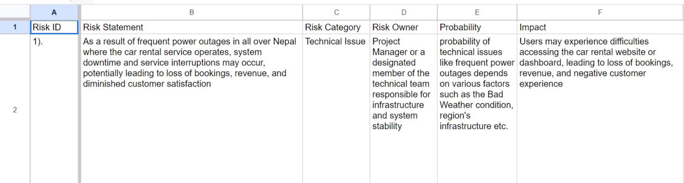

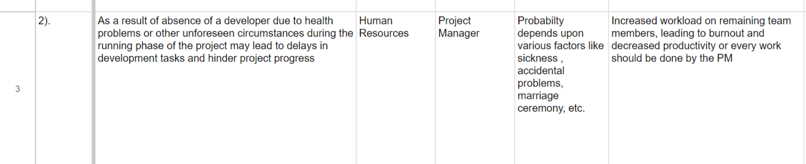

Risk Score, Response type , Mitigation plan and remarks of Risk analysis are as follows:-

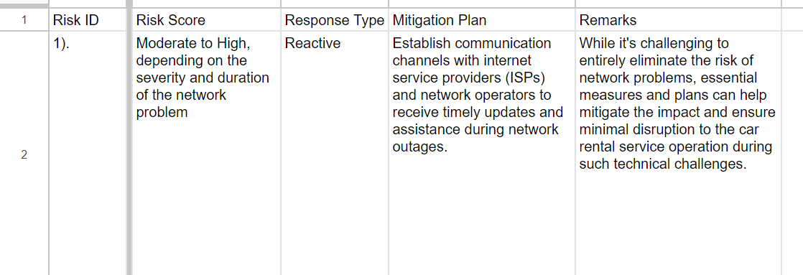

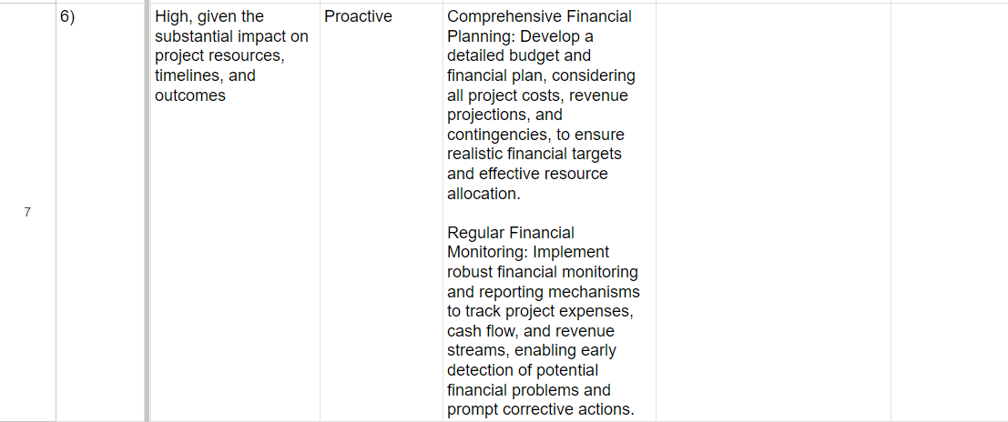

So above all risk analysis are faced during the Sprint 1 and this Risk analysis is also for coming Sprint 2 as well as if any consequences occur in future on that based it is also analyzed. I had attached Risk analysis report as screenshot also providing direct link of Report which is given below: -

Risk Analysis Report Link :- <https://docs.google.com/spreadsheets/d/1C-8cx8xxzAmD3WfjLuEFnYXayLTrUitaInkFX8gRAKY/edit?usp=sharing>

### 1.4. Plan and control risk responses.

There are different ways to control the risk via planning. Some of them are as follows: -

1. Avoid

If there arises a risk like not having enough team members (absentees) for team members, our team should try to avoid or steer away from it. For example, confirm that everyone knows about the team meeting and ask them nicely to come, if also they not come then avoid them.

1. Mitigate

The Risk like not completion of task on time, our team can try to make better plan and ask everyone that which time they are available for meeting so that they can join it and confirming the time, PM should Schedule the meeting. In this way we can know the actual work progress via meeting and go forward for completion of task without any obstacles.

1. Transfer

If risk like having no proper coding skills for particular task, our team should ask another developers for that task who is good at coding.

1. Accept

In some cases, we are working together in a group for a project. So in that case not every members are well skilled so we have to accept that it’s ok not to be perfect but try out best to do.

## 2]. Project and People Management

### 2.1. Gantt Chart

The Gantt Chart Provides a visual representation of project task division to schedule , track or manage the proper time. Gantt Chart helps to track the Progress of Project. Soo for Our project Gantavya Car rental Service, The Gantt chart are as follows:-

Fig 1 : Gantt Chart of Gantavya Car Rental Service

### 2.2.] Slack

a) First of all, Ask everyone to join the Slack for formal communication on project tipic after inviting every team members. Then start communicating on topic like Joining the JIRA tool.

b) After Joining the JIRA , I had created the product backlog with proper description and subtask and then ask to developers for review so that they can understand easily or not , the task assigned there. For that review , As a pm I had schedule a meeting for review of product backlog.

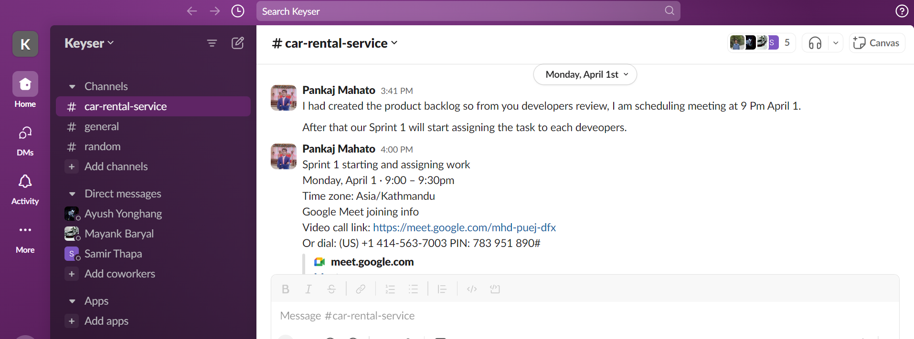

c) We had also communicate though Gmail chat , Which are as follows:-

I had make a report for Case based Research on Given Project and provide to my team members.

### 2.3]. Meeting Minute

#### 2.3.1.] First Meeting with Client minute

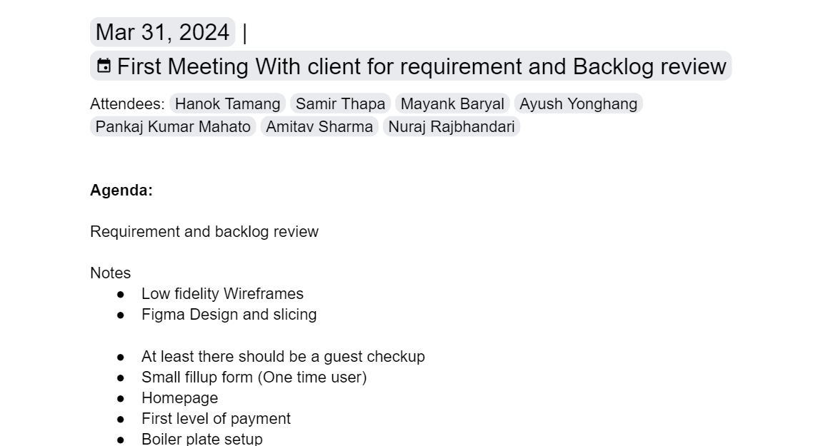

### 2.3.2]. Second Meeting with client minute:

### 2.3.3]. Third Meeting with clients:

#### 2.3.4]. Backlog Review Meeting among team members.

#### 2.3.5]. Product backlog and Sprint planning

#### 3.3.6]. Epics , User Story and task related

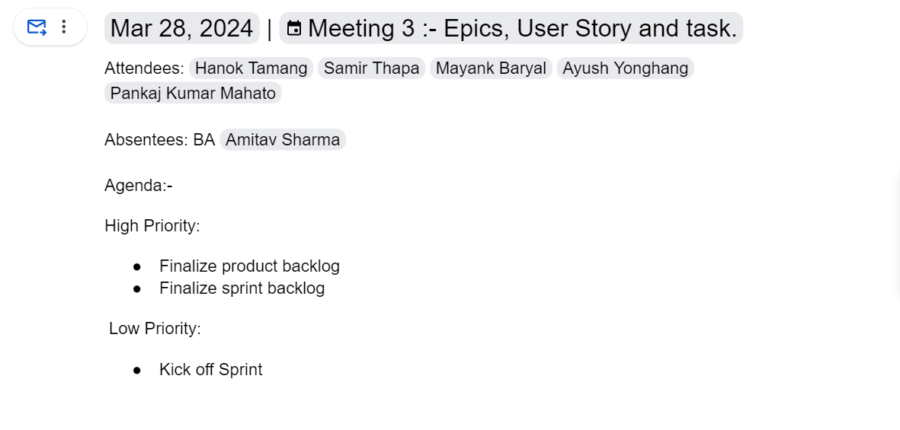

#### 2.3.7]. Sprint 1 Retrospective Discussion

## 2.4]. Meeting Schedule

### 2.4]. Attendance

#### 2.4.1] Meeting with team members attendance

|  |  |  |  |  |  |  |
| --- | --- | --- | --- | --- | --- | --- |
| Date | Pankaj Kumar Mahato (PM) | Amitav Sharma (BA) | Samir Thapa (Frontend Developer) | Hanok Tamang (Backend developer) | Mayank Baryal (Backend Developer) | Ayush Yonghang  (Frontend developer) |
|  |  |  |  |  |  |  |
|  |  |  |  |  |  |  |
|  |  |  |  |  |  |  |
|  |  |  |  |  |  |  |
|  |  |  |  |  |  |  |

2.4.2] Meeting with client attendance

|  |  |  |  |  |  |  |  |
| --- | --- | --- | --- | --- | --- | --- | --- |
| Date | Nuraj Rajbhandari (Client) | Pankaj Kumar Mahato (PM) | Amitav Sharma (BA) | Samir Thapa (Frontend Developer) | Hanok Tamang (Backend developer) | Mayank Baryal (Backend Developer) | Ayush Yonghang  (Frontend developer) |
| 2024/04/07 | P | P | P | P | P | P | P |
| 2024/04/14 | A (PAT client came) | P | A | A | A | P | A |
| 2024/04/21 | P | A | A | P | P | P | P |

# Appendix B

## Evidence of Good communication and file sharing

## Evidence of Continuing Personal Development (CPD)

## Evidence of Issue Tracking